**Emotional responses to prosocial messages increase willingness to self-isolate during the COVID-19 pandemic**

Joseph Heffner1, Marc-Lluís Vives1, and Oriel FeldmanHall1,2

1Department of Cognitive, Linguistic, Psychological Sciences, Brown University, Providence RI 02912

2Carney Institute for Brain Science, Brown University, Providence RI 02912

*Corresponding Author*

Oriel FeldmanHall

Brown University

190 Thayer St.

Providence, RI 02912

**Abstract**

The COVID-19 pandemic may be one of the greatest modern societal challenges that requires widespread collective action and cooperation. While a handful of actions can help reduce pathogen transmission, the most critical behavior is to self-isolate. But what types of public health messages can aid compliance with such extreme social distancing measures? Public health messages designed to facilitate compliance have often used emotional language, ranging from negative fear appeals (e.g., millions of people will die) to positive prosocial appeals (e.g., everyone’s actions help society). Understanding how these types of messages tap into the different dimensions of emotion—a mechanism documented in other domains to be an essential component of behavior change—is critical for creating successful public health campaigns related to COVID-19. In a U.S. representative sample (N = 955), we presented two messages that leveraged either fear or prosocial language, and asked participants to report their emotional reactions and their willingness to self-isolate. While results show that both types of interventions increased willingness to self-isolate (Cohen’s *d* = .41), compared to the fear message, the success of the prosocial message was more dependent on the magnitude of emotional response on both the arousal and valence dimensions. Our results suggest that prosocial interventions have the potential to be associated with greater compliance if they evoke highly positive emotional responses.

**Keywords**: emotion, COVID-19, interventions, fear, prosocial

**Introduction**

In the span of just a few months, COVID-19 has ripped through almost every country, infecting close to 2 million people, killing over 120,000 (John Hopkins University, 2020), and crippling dozens of economies. Without a vaccine in hand, it seems that the virus can only be slowed by extreme behavioral change and societal coordination (Arenas et al., 2020). Some countries, like South Korea and Taiwan, were quick to respond by instituting enforced quarantines and entreating citizens to practice social distancing (Beech, 2020; Fisher & Sang-Hun, 2020). Other countries, like the United States and the United Kingdom, were reluctant to impose widespread shelter-in-place measures (The Associated Press, 2020). In America, for example, individual states began gradually issuing social isolation practices to combat the spread of the virus (Mervosh, Lu, & Swales, 2020). In both cases, the countries hoped their citizens would readily comply with public health messages. Preliminary reports, however, show vast differences in people’s willingness to practice measures that can reduce pathogen transmission (Lunn et al., 2020).

At present, public health advisors, such as the World Health Organization, argue that mitigating the spread of COVID-19 necessitates citizens swiftly adapt and change their usual habits to obey new social distancing measures (World Health Organization, 2020). Given the evidence that emotional engagement is a critical component of behavior change (Bagozzi & Pieters, 1998; Hartley & Phelps, 2010; Perugini & Bagozzi, 2001), widespread and rapid adoption is unlikely to occur without public health messages that include emotional appeals (Myers, Nisbet, Maibach, & Leiserowitz, 2012). But which emotionally evocative messaging is the most effective in garnering such extraordinary behavior change?

Amidst the growing COVID-19 pandemic, some appeals have leveraged a classic fear mongering approach: leveraging fear language to highlight grim outcomes, staggering death tolls, and an inability for an overwhelmed health system to treat citizens (Pueyo, 2020). There is good reason for adopting a fear framework, as negative emotions can influence attitudes and behaviors (Tannenbaum et al., 2015) by increasing attention towards the message (Baron, 1994) and enhancing perceptions of risk associated with negative outcomes (Leiserowitz, 2006). By emphasizing the potential danger and harm that will ensue if individuals fail to adopt recommendations, fear can be a powerful avenue for stimulating behavior change. However, positive emotional appeals can play a potent role in public health campaigns as well (Lewis, Watson, White, & Tay, 2007), serving as a distinct contrast to fear-based appeals. For example, positive emotion can increase reception to public health campaigns, and prosocial emotions such as empathy and compassion may reframe issues as being more personally relevant (Monahan, 1995). Some recent research illustrates that public health messages that appeal to societal and communal benefits (e.g., help protect your fellow citizens)—rather than focusing on benefits to the self (e.g., protect yourself)—may be an effective method (Kelly & Hornik, 2016; Li, Taylor, Atkins, Chapman, & Galvani, 2016) for communicating public health recommendations related to COVID-19 (Jordan, Yoeli, & Rand, 2020).

With every progressive day bringing more infections and deaths from COVID-19, it is vital to understand how different emotional frames are effective in driving behavioral compliance. Here, we examine how the efficacy of public health messaging is linked with emotional reactions. We test emotional reactions using a model of emotion that partitions experiences into the core affective dimensions of valence (pleasurableness) and arousal (alertness/activation; Russell & Barrett, 1999). Using this framework, we can characterize the heterogeneity in emotional responses to both fear and prosocial appeals. Given previous evidence that negative and positive emotions can be effective at persuasion (DeSteno, Petty, Rucker, Wegener, & Braverman, 2004), we expect that both fear and prosocial calls to action will elicit willingness to self-isolate because of COVID-19.

An open question, however, is whether fear and prosocial appeals operate from the same emotional mechanism, since less is known if both valence and arousal—and their interaction—are consequential for message efficacy. Based on the strong relationship between the intensity of emotional engagement (i.e., arousal) and cognitive processes, such as learning and memory (Kensinger & Corkin, 2004; Storbeck & Clore, 2008), emotional intensity should increase willingness to change behavior in accordance with public health recommendations. For example, past research on addiction demonstrates that emotionally impactful advertisements aimed at preventing tobacco use (e.g., intense, graphic images that illustrate the dangers associated with smoking), are recalled more readily than those that are less fearful and emotionally evocative (Biener, Wakefield, Shiner, & Siegel, 2008). Because evocative messages are more memorable, arousal may enhance memory by increasing attention (Reisberg & Heuer, 1992) and slowing forgetting (Sharot & Phelps, 2004)—which may in turn result in greater compliance. However, this research typically uses negatively valenced language, and much less is known about how arousal interacts with positively valenced stimuli, especially when influencing public health messaging efficacy. Here, we compare these emotional mechanisms—greater emotional arousal and experienced valence—to see how they subserve willingness to comply with health recommendations during the COVID-19 pandemic.

**Methods**.

*Participants.* On March 24th, 2020, we began recruitment through the online site Prolific to collect a representative United States sample (based on sex, age, and ethnicity; Prolific Team, 2019) of N = 1000. Participants received monetary compensation and provided informed consent in a manner approved by Brown University’s Institutional Review Board. The experiment was conducted within a week of the COVID-19 infection reports in the United States reaching 10,000 (John Hopkins University, 2020). We only recruited U.S. participants to ensure that national messages and questionnaires specific to the United States would be relevant. For example, on March 13th, the White House released a proclamation declaring a national state of emergency related to the COVID-19 outbreak (The White House, 2020) and on March 16th, social distancing guidelines were issued in the United States (The White House & Centers for Disease Control and Prevention, 2020). Using the preregistered exclusion criterion that aimed to ensure high quality data, we excluded 45 individuals’ data using a conservative measure of noncompliance based on instructions for an emotion classification task (see *Measuring Emotional Experiences* for a description of the task). This resulted in a final sample of 955 participants (506 females; age *M* = 44.8, *SD* = 15.9).

*General procedure.* Here we detail every measure that participants responded to, however, only the intervention measures (detailed below) and a single item related to COVID-19 behavior (“I stayed at home”, which provided a baseline for COVID-19 self-isolation behavior), were analyzed for this experiment. All other measures were collected for another experiment, whose hypotheses and methods were preregistered on OSF (https://osf.io/ujfny/). All participants completed a series of tasks and questionnaires in the following order: an emotion classification task, a variety of self-report questionnaires with a randomly presented order including the emotion regulation questionnaire (Gross & John, 2003), interpersonal regulation questionnaire (Williams, Morelli, Ong, & Zaki, 2018), extraversion and neuroticism subscales (Soto & John, 2017), intolerance of uncertainty (Carleton, Norton, & Asmundson, 2007), and clinical measures of depression (Radloff, 1977), anxiety (Spitzer, Kroenke, Williams, & Lowe, 2006), and alexithymia (Bagby, Parker, & Taylor, 1994), a questionnaire that assessed their knowledge of COVID-19, a fear intervention, questionnaires that assessed behavioral responses towards COVID-19, fear of COVID-19, media consumption of COVID-19, motives related to COVID-19 behaviors, social support related to COVID-19, information about work related to COVID-19, an altruism intervention, and demographics.

*Interventions*. In a within-subject design, participants were given two prompts that we created. One, which we label here for ease of reading as the “fear” intervention, was inspired by a recent Medium article (Pueyo, 2020) that tapped into people’s fear of COVID-19: *“The coronavirus is coming for you. When it does, your healthcare system will be overwhelmed. Your fellow citizens will be turned away at the hospital doors. Exhausted healthcare workers will break down. Millions will die. The only way to prevent this crisis is social distancing today.”* After reading this prompt, participants were asked three questions: (a) How does this statement make you feel? (responses recorded using a granular emotion measure, see details below); (b) On a scale from 0 (not at all) to 100 (completely), how willing are you to self-isolate?; (c) On a scale from 0 (no change) to 100 (a lot of change), how much does the previous statement change your willingness to self-isolate? In the second prompt (which was temporally spaced by multiple questionnaires, see above under general procedure), participants were given a prosocial intervention (labelled here “altruism” intervention), that was designed to be as similar as possible in structure to the fear prompt, but which emphasized prosocial actions: *“Help save our most vulnerable. Together, we can stop the coronavirus. Everyone’s actions count, every single person can help to slow the crisis. We have the tools to solve this problem. Together, by self-isolating we can save millions of lives.”* After this prompt, participants were again asked the three questions denoted above.

*Measuring emotional experiences*. At the beginning of the experiment, participants completed an emotion classification task using the *dynamic Affective Representation Mapping* (dARM)tool(a measure we have used in our prior work; Heffner, Son, & FeldmanHall, under review) that was adapted from the affect grid used in past research (Russell, Weiss, & Mendelsohn, 1989). This measure allows participants to rate their affective experiences on a subjective map where the horizontal axis characterizes an unpleasant-pleasant dimension (i.e., valence), and the vertical axis characterizes a low-high activation dimension (i.e., arousal). The dARM has a sampling resolution of 500 x 500 pixels, enabling us to measure fine-grained self-reports of both the valence and arousal dimensions. The emotional classification task asked participants to rate 20 canonical emotion words (e.g., angry, sad, happy) prior to receiving either intervention, which ensured that participants were able to effectively use the dARM to accurately rate their emotional experiences (i.e., “How does this statement make you feel”) before they received either intervention. Critically, participants were told where to rate neutral in the instructions: “*The center of the square represents a neutral, average, everyday feeling. It is neither positive nor negative*”. Our preregistered exclusion criterion was to remove participants who failed to rate neutral within a 100-pixel box around the center (N = 45/1000).

*Analysis.* We used linear mixed-effects regressions to predict participants’ self-reported 1) willingness to self-isolate, and 2) change in willingness to self-isolate after reading the interventions. Predictor variables were participant’s emotional ratings on the dARM, separated by the arousal and valence dimensions, as well as the type of intervention (fear/altruism). Separate regressions were run for predicting willingness to self-isolate (labeled “willingness”) and change in willingness (labeled “change”). All regressions were run using the nlme package in R (Pinheiro, Bates, DebRoy, Sarkar, & R Core Team, 2020).

**Results**

To examine the effectiveness of the fear and altruism interventions, we first examined people’s current reported self-isolation behavior. We found that, on average, people reported that they were staying at home 87.3% of the time because of COVID-19 (“I stayed home” ranging from 0 – not at all to 100 – all the time). Although most people were already reporting engaging in self-isolationist measures, it is still possible that the two interventions could encourage people to engage even more in these behaviors. To create a measure of each intervention’s effectiveness, we subtracted reports of current self-isolation from reported willingness to self-isolate after reading the fear and altruism interventions (both scales ranged from 0-100). Comparing interventions’ scores to 0 (i.e, no effect of intervention) revealed that both the fear intervention (*M* = 6.44, *SD* = 15.41; *t*(954) = 12.92, *p* < .001; Cohen’s *d* = .42) and altruism intervention (*M* = 6.50, *SD* = 15.71; *t*(954) = 12.79, *p* < .001; Cohen’s *d* = .41) increased willingness to self-isolate, confirming the efficacy of both interventions. We then examined whether the fear or altruism intervention produced differences in people’s reported willingness to self-isolate (termed “willingness”; Fig. 1A), as well as their reported change in self-isolation behavior after reading the intervention (termed “change”). Although participants reported high levels of willingness to self-isolate after reading both the fear intervention (*M* = 93.75, *SD* = 12.96) and the altruism intervention (*M* = 93.81, *SD* = 13.43), a paired sample t-test showed the two interventions did not produce significantly different reports of willingness (*t*(954) = 0.25, *p* = .81) or changes in self-isolating (*t*(954) = 0.17, *p* = .87). Together, these results illustrate that both altruism and fear interventions nudged willingness to self-isolate in comparable ways to help mitigate the spread of the virus.

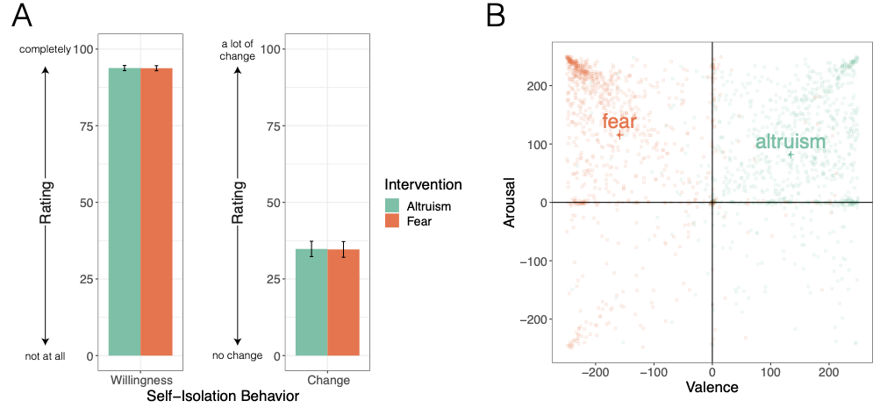

***Figure 1. Intervention Results. A) Self-isolation behavior after reading each intervention****. Participants reported how willing they were to self-isolate from 0 (not at all) to 100 (completely) and how the intervention changed their willingness to self-isolate from 0 (no change) to 100 (a lot of change). Participants report similar levels of willingness and change in self-isolation to the altruism and fear interventions.* ***B). Emotional experiences after interventions****. Participants reported how each intervention made them feel on the dynamic Affective Representation Mapping (dARM) measure, which simultaneously captures experienced valence and arousal at a granular level. Raw data has been plotted as transparent dots and the group averages are plotted below the intervention labels. All error bars are 95% confidence intervals (CIs).*

While the interventions were similarly effective (Fig. 1A), examining the emotional reactions to both interventions revealed they were associated with distinct emotional experiences. The average emotional response to the fear intervention was very unpleasant and highly arousing while the average emotional response to the altruism intervention was fairly pleasant and moderately arousing (Fig. 1B). These emotional responses to the fear intervention were heavily clustered in the upper-left corner of the *dARM*, indicating more homogeneity in emotional responses compared to the prosocial intervention responses. Formal tests comparing experienced arousal and valence between the two interventions revealed that the fear intervention was experienced as significantly more arousing (*M* = 115.46, *SD* = 126.60) than the altruism intervention (*M* = 81.88, *SD* = 99.37; paired sample *t*(954) = 7.90, *p* < .001; Cohen’s *d* = .26). Moreover, while the fear intervention was unsurprisingly experienced as significantly more negatively valenced (*M* = -158.67, *SD* = 94.28) than the altruism intervention (*M* = 134.60, *SD* = 90.95; *t*(954) = -68.50, *p* < .001; Cohen’s *d* = 2.22), it was critically experienced as more unpleasant than the altruism intervention was experienced as pleasant (absolute value of valence, *t*(954) = 7.56, *p* < .001; Cohen’s *d* = .24). This suggests that participants had a stronger emotional reaction on both dimensions to the fear intervention than the altruism intervention.

Examining how these emotional responses influenced willingness to self-isolate revealed that the strength of experienced arousal and valence was more associated with willingness to self-isolate for the altruism intervention compared to the fear intervention (arousal: interaction β = 0.07 ± 0.03, p = .023; valence: interaction β = 0.16 ± 0.05, p < .001; Fig. 2). Indeed, the fact that the simple effects of the fear intervention (dark red and dark purple lines in Fig. 2) were not significant suggests that the efficacy of the fear intervention does not rely on the strength of the emotional response, whereas the altruistic intervention does. A similar behavioral pattern was found for changes in self-isolation (Fig. 3), where the effect of valence on behavior change was significantly higher for the altruism intervention than the fear intervention (interaction β = 0.24 ± 0.06, p < .001). However, unlike before, the relationship between arousal and change was similar across both interventions (interaction β = 0.02 ± 0.04, p = .644), suggesting that increases in arousal for both interventions lead to more intention to change behavior.

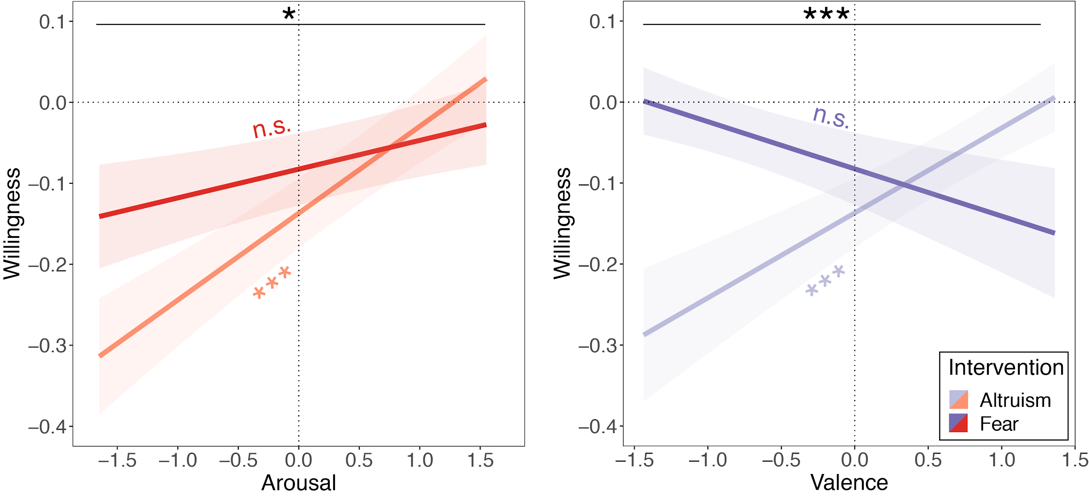

***Figure 2. Emotional experience predicts reported willingness to self-isolate after altruistic intervention.*** *Willingness to self-isolate is plotted for arousal and valence after reading the altruism and fear interventions. ‘Willingness’ has been normalized (standardized and mean-centered) while arousal and valence have been standardized without being mean-centered (as the 0 point on the scale reflects a neutral feeling). Lines represent regression fits and shaded areas reflect ±1 standard errors (SEs).*

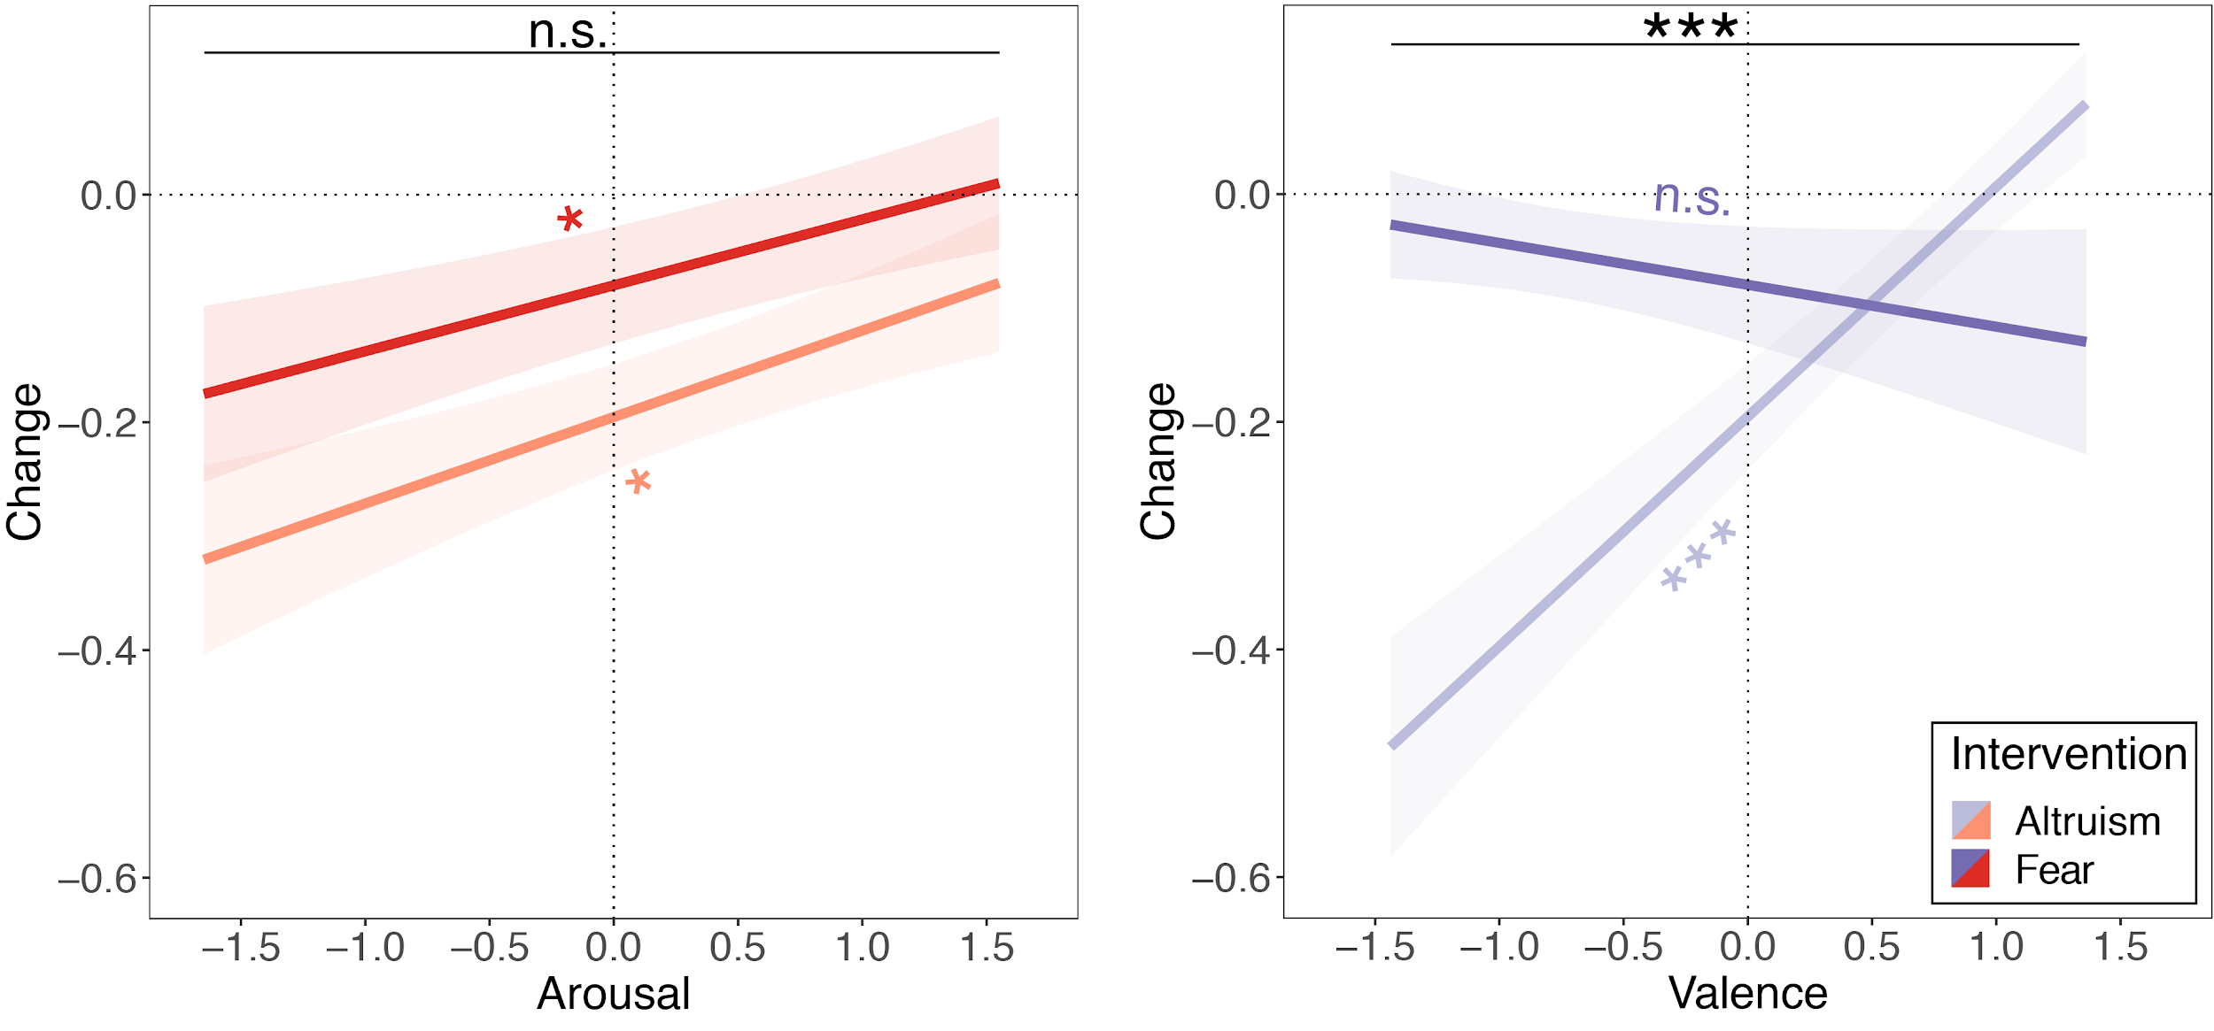

***Figure 3. Emotional experience predicts reported changes in self-isolation after altruistic intervention.*** *Change in reported self-isolation is plotted for arousal and valence after reading the altruism and fear interventions. Change has been normalized (standardized and mean-centered) while arousal and valence have been standardized without being mean-centered (as the 0 point on the scale reflects a neutral feeling). Lines represent regression fits and shaded areas reflect ±1 standard errors (SEs).*

**Discussion**

The efficacy of public health messages is crucial for successfully combating large public health crises such as the COVID-19 pandemic. Problematically, the behaviors associated with preventing the spread of the virus are difficult to adhere to, as they include vigilant hand washing, donning facial masks, and most disruptively, practicing extreme social distancing measures. This makes it challenging for public health officials to create messages that are effective in motivating behavior change. Here, we explore how emotion shapes the efficacy of two different types of public health messages, one that graphically taps into people’s fear and one that highlights the welfare of society. Unlike previous research that has found prosocial frames to be more effective than fear frames (Shen, 2011), we find that both fear and prosocial messages were equally effective in stimulating willingness to engage in prevention focused health behaviors. While fear messages created a stronger emotional reaction (which were more negative and arousing) than the prosocial message, the efficacy of the fear intervention depended less on the strength of the emotional response compared to the prosocial intervention. In contrast, the prosocial message was more effective at boosting willingness to self-isolate if it produced a strong, positive, and arousing emotional response.

These findings reveal that although fear and prosocial interventions were similarly successful in changing people’s willingness to socially isolate, they do not operate from the same emotional mechanisms. While successful prosocial messages depend on strong, positive emotional engagement, effective messages leveraging fear mongering language are less reliant on the strength of emotional reactions. Given the lack of observable relationship between emotion and reported willingness to self-isolate in response to fear-mongering language, other mechanisms such as a negativity bias (Rozin & Royzman, 2001) or selective attention to negative information (Carretié, Mercado, Tapia, & Hinojosa, 2001) may subserve the efficacy of fear messaging. Moreover, because emotional responses did not yield influence on willingness to self-isolate, designing a message with more graphic and emotionally evocative language would likely not improve the success of a fear-mongering appeal. Since self-isolation and monetary hardship related to economic downturns can result in increases in depression and anxiety (Brooks et al., 2020), changing behavior without resorting to fear mongering tactics would be important for public health officials to consider when designing public service announcements. Indeed, it is possible that messages associated with positive emotions may help buffer against any unnecessary increases in clinical mood disorders. Simply put, messages that promote behavioral change while simultaneously appealing to positive emotions are needed now more than ever.

It is worth noting, however, that participants in our studies were simply asked to report their willingness to change their behaviors. Research on message interventions illustrates that reported behavior change does not always coincide with actual behavior changes in the real world (FeldmanHall et al., 2012; Gibbons, Gerrard, Ouellette, & Burzette, 1998). Although previous work has demonstrated that perceived message efficacy is a relatively good measure of actual effectiveness (Dillard, Shen, & Vail, 2007; Dillard, Weber, & Vail, 2007), it will be important to confirm that these results generalize to actual behavior, where readers are being bombarded with many different messages and likely exhibit divided attention when consuming news or reading public health messages. Furthermore, it is also critical to highlight that, while the rapid transmission of COVID-19 is unfolding on a global scale, our sample was limited, by design, to the United States. As there are known cultural differences in how emotion is conceptually represented (Jackson et al., 2019) and expressed (Gendron, Roberson, van der Vyver, & Barrett, 2014), caution should be taken when interpreting the widespread applicability of these results since findings may not translate cross-culturally.

As of the beginning of April 2020, the United States had still not achieved widespread compliance with social isolationist measures (Canipe, 2020; Fitzpatrick & DeSalvo, 2020), despite repeated calls for citizens to shelter in place from specific States. To help speed the global goal of “flattening the curve” (Qualls et al., 2017), governments and public health officials need to find the most effective messaging for stimulating behavioral compliance. While appealing to fear to mobilize society during threats might be tempting to motivate behavioral compliance, we found that prosocial calls to action not only created more positive emotions, but they also elicited just as much willingness to self-isolate compared to deploying fear-mongering language. Although these are preliminary results, it suggests that when collaborative efforts are needed to fight a global pandemic, interventions that appeal to altruism might have more to gain than those that appeal to fear.

**Data and code availability**

Behavioral data and analysis script of the reported experiment are available at: https://github.com/jpheffne/covid_intervention.

**Acknowledgments**

We thank Logan Bickel for scientific discussion and helpful comments. The research was funded by a Center of Biomedical Research Excellence grant P20GM103645 from the National Institute of General Medical Sciences. The funders had no role in the study design, data collection and analysis, decision to publish or preparation of the manuscript.

**Author contributions**

J.H., M.L.V. and O.F.H. designed the study. J.H. collected and analyzed the data. J.H., M.L.V. and O.F.H. wrote the manuscript.

**Competing interests**

The authors declare no competing or conflict of interests.

**References**

Arenas, A., Cota, W., Gomez-Gardenes, J., Gomez, S., Granell, C., Matamalas, J. T., . . . Steinegger, B. (2020). Derivation of the effective reproduction number R for COVID-19 in relation to mobility restrictions and confinement. *medRxiv*, 2020.2004.2006.20054320. doi:10.1101/2020.04.06.20054320

Bagby, R. M., Parker, J. D. A., & Taylor, G. J. (1994). The twenty-item Toronto Alexithymia scale—I. Item selection and cross-validation of the factor structure. *Journal of Psychosomatic Research, 38*(1), 23-32. doi:<https://doi.org/10.1016/0022-3999(94)90005-1>

Bagozzi, R. P., & Pieters, R. (1998). Goal-directed Emotions. *Cognition and Emotion, 12*(1), 1-26. doi:10.1080/026999398379754

Baron, J. (1994). *Thinking and deciding, 2nd ed*. New York, NY, US: Cambridge University Press.

Beech, H. (2020). Tracking the coronavirus: How crowded asian cities tackled an epidemic. Retrieved from <https://www.nytimes.com/2020/03/17/world/asia/coronavirus-singapore-hong-kong-taiwan.html>

Biener, L., Wakefield, M., Shiner, C. M., & Siegel, M. (2008). How Broadcast Volume and Emotional Content Affect Youth Recall of Anti-Tobacco Advertising. *American Journal of Preventive Medicine, 35*(1), 14-19. doi:<https://doi.org/10.1016/j.amepre.2008.03.018>

Brooks, S. K., Webster, R. K., Smith, L. E., Woodland, L., Wessely, S., Greenberg, N., & Rubin, G. J. (2020). The psychological impact of quarantine and how to reduce it: rapid review of the evidence. *The Lancet, 395*(10227), 912-920. doi:<https://doi.org/10.1016/S0140-6736(20)30460-8>

Canipe, C. (2020). The social distancing of America. Retrieved from <https://graphics.reuters.com/HEALTH-CORONAVIRUS/USA/qmypmkmwpra/>

Carleton, R. N., Norton, M. A. P. J., & Asmundson, G. J. G. (2007). Fearing the unknown: A short version of the Intolerance of Uncertainty Scale. *Journal of Anxiety Disorders, 21*(1), 105-117. doi:<https://doi.org/10.1016/j.janxdis.2006.03.014>

Carretié, L., Mercado, F., Tapia, M., & Hinojosa, J. A. (2001). Emotion, attention, and the ‘negativity bias’, studied through event-related potentials. *International Journal of Psychophysiology, 41*(1), 75-85. doi:<https://doi.org/10.1016/S0167-8760(00)00195-1>

DeSteno, D., Petty, R. E., Rucker, D. D., Wegener, D. T., & Braverman, J. (2004). Discrete emotions and persuasion: the role of emotion-induced expectancies. *J Pers Soc Psychol, 86*(1), 43-56. doi:10.1037/0022-3514.86.1.43

Dillard, J. P., Shen, L., & Vail, R. G. (2007). Does Perceived Message Effectiveness Cause Persuasion or vice Versa? 17 Consistent Answers. *Human Communication Research, 33*(4), 467-488. doi:10.1111/j.1468-2958.2007.00308.x

Dillard, J. P., Weber, K. M., & Vail, R. G. (2007). The Relationship Between the Perceived and Actual Effectiveness of Persuasive Messages: A Meta-Analysis With Implications for Formative Campaign Research. *Journal of Communication, 57*(4), 613-631. doi:10.1111/j.1460-2466.2007.00360.x

FeldmanHall, O., Mobbs, D., Evans, D., Hiscox, L., Navrady, L., & Dalgleish, T. (2012). What we say and what we do: the relationship between real and hypothetical moral choices. *Cognition, 123*(3), 434-441. doi:10.1016/j.cognition.2012.02.001

Fisher, M., & Sang-Hun, C. (2020). How south korea flattened the curve. Retrieved from <https://www.nytimes.com/2020/03/23/world/asia/coronavirus-south-korea-flatten-curve.html>

Fitzpatrick, J., & DeSalvo, K. (2020). Helping public health officals combat COVID-19. Retrieved from <https://www.blog.google/technology/health/covid-19-community-mobility-reports>

Gendron, M., Roberson, D., van der Vyver, J. M., & Barrett, L. F. (2014). Perceptions of emotion from facial expressions are not culturally universal: Evidence from a remote culture [Press release]

Gibbons, F. X., Gerrard, M., Ouellette, J. A., & Burzette, R. (1998). Cognitive antecedents to adolescent health risk: Discriminating between behavioral intention and behavioral willingness. *Psychology & Health, 13*(2), 319-339. doi:10.1080/08870449808406754

Gross, J. J., & John, O. P. (2003). Individual differences in two emotion regulation processes: implications for affect, relationships, and well-being. *J Pers Soc Psychol, 85*(2), 348-362. doi:10.1037/0022-3514.85.2.348

Hartley, C. A., & Phelps, E. A. (2010). Changing Fear: The Neurocircuitry of Emotion Regulation. *Neuropsychopharmacology, 35*(1), 136-146. doi:10.1038/npp.2009.121

Heffner, J., Son, J.-Y., & FeldmanHall, O. (under review). Emotion prediction errors guide socially adaptive behavior.

Jackson, J. C., Watts, J., Henry, T. R., List, J.-M., Forkel, R., Mucha, P. J., . . . Lindquist, K. A. (2019). Emotion semantics show both cultural variation and universal structure. *Science, 366*(6472), 1517. doi:10.1126/science.aaw8160

John Hopkins University. (2020). COVID-19 Map. Retrieved from <https://coronavirus.jhu.edu/map.html>

Jordan, J., Yoeli, E., & Rand, D. (2020). Don’t get it or don’t spread it? Comparing self-interested versus prosocially framed COVID-19 prevention messaging. doi:10.31234/osf.io/yuq7x

Kelly, B. J., & Hornik, R. C. (2016). Effects of Framing Health Messages in Terms of Benefits to Loved Ones or Others: An Experimental Study. *Health Communication, 31*(10), 1284-1290. doi:10.1080/10410236.2015.1062976

Kensinger, E. A., & Corkin, S. (2004). Two routes to emotional memory: Distinct neural processes for valence and arousal. *Proc Natl Acad Sci U S A, 101*(9), 3310. doi:10.1073/pnas.0306408101

Leiserowitz, A. (2006). Climate Change Risk Perception and Policy Preferences: The Role of Affect, Imagery, and Values. *Climatic Change, 77*(1), 45-72. doi:10.1007/s10584-006-9059-9

Lewis, I. M., Watson, B., White, K. M., & Tay, R. (2007). Promoting public health messages: Should we move beyond fear-evoking appeals in road safety? *Qual Health Res, 17*(1), 61-74. doi:10.1177/1049732306296395

Li, M., Taylor, E. G., Atkins, K. E., Chapman, G. B., & Galvani, A. P. (2016). Stimulating Influenza Vaccination via Prosocial Motives. *PLoS One, 11*(7), e0159780. doi:10.1371/journal.pone.0159780

Lunn, P., Belton, C., Lavin, C., McGowan, F., Timmons, S., & Robertson, D. (2020). Using behavioural science to help fight the coronavirus. ESRI Working Paper No. 656 March 2020. In.

Mervosh, S., Lu, D., & Swales, V. (2020). See which states and cities have told residents to stay at home. Retrieved from <https://www.nytimes.com/interactive/2020/us/coronavirus-stay-at-home-order.html>

Monahan, J. L. (1995). Thinking positively: Using positive affect when designing health messages. In E. Maibach & R. L. Parrott (Eds.), *Designing health messages: Approaches from communication theory and public health practice* (pp. 81-98). Thousand Oaks, CA: SAGE Publications, Inc.

Myers, T. A., Nisbet, M. C., Maibach, E. W., & Leiserowitz, A. A. (2012). A public health frame arouses hopeful emotions about climate change. *Climatic Change, 113*(3), 1105-1112. doi:10.1007/s10584-012-0513-6

Perugini, M., & Bagozzi, R. P. (2001). The role of desires and anticipated emotions in goal-directed behaviours: Broadening and deepening the theory of planned behaviour. *British Journal of Social Psychology, 40*(1), 79-98. doi:10.1348/014466601164704

Pinheiro, J., Bates, D., DebRoy, S., Sarkar, D., & R Core Team. (2020). Linear and nonlinear mixed effects models. Retrieved from <https://CRAN.R-project.org/package=nlme>

Prolific Team. (2019). Representative samples on prolific. Retrieved from <https://researcher-help.prolific.co/hc/en-gb/articles/360019236753-Representative-Samples-on-Prolific>

Pueyo, T. (2020). Coronavirus: Why you must act now. Retrieved from <https://medium.com/@tomaspueyo/coronavirus-act-today-or-people-will-die-f4d3d9cd99ca>

Qualls, N. L., Levitt, A. M., Kanade, N., Wright-Jegede, N., Dopson, S., Biggerstaff, M., . . . Uzicanin, A. (2017). Community mitigation guidelines to prevent pandemic influenza — United States, 2017. *MMWR. Recommendations and reports : Morbidity and mortality weekly report. Recommendations and reports, 66*(1). Retrieved from <https://stacks.cdc.gov/view/cdc/45220>

Radloff, L. S. (1977). The CES-D Scale: A self-report depression scale for research in the general population [Press release]

Reisberg, D., & Heuer, F. (1992). Remembering the details of emotional events. In *Affect and accuracy in recall: Studies of "flashbulb" memories.* (pp. 162-190). New York, NY, US: Cambridge University Press.

Rozin, P., & Royzman, E. B. (2001). Negativity Bias, Negativity Dominance, and Contagion. *Personality and Social Psychology Review, 5*(4), 296-320. doi:10.1207/S15327957PSPR0504_2

Russell, J. A., & Barrett, L. F. (1999). Core affect, prototypical emotional episodes, and other things called emotion: Dissecting the elephant. *Journal of Personality and Social Psychology, 76*(5), 805-819. doi:10.1037/0022-3514.76.5.805

Russell, J. A., Weiss, A., & Mendelsohn, G. A. (1989). Affect Grid: A single-item scale of pleasure and arousal. *Journal of Personality and Social Psychology, 57*(3), 493-502. doi:10.1037/0022-3514.57.3.493

Sharot, T., & Phelps, E. A. (2004). How arousal modulates memory: Disentangling the effects of attention and retention. *Cognitive, Affective, & Behavioral Neuroscience, 4*(3), 294-306. doi:10.3758/CABN.4.3.294

Shen, L. (2011). The Effectiveness of Empathy- Versus Fear-Arousing Antismoking PSAs. *Health Communication, 26*(5), 404-415. doi:10.1080/10410236.2011.552480

Soto, C. J., & John, O. P. (2017). Short and extra-short forms of the Big Five Inventory–2: The BFI-2-S and BFI-2-XS. *Journal of Research in Personality, 68*, 69-81. doi:<https://doi.org/10.1016/j.jrp.2017.02.004>

Spitzer, R. L., Kroenke, K., Williams, J. B., & Lowe, B. (2006). A brief measure for assessing generalized anxiety disorder: the GAD-7. *Arch Intern Med, 166*(10), 1092-1097. doi:10.1001/archinte.166.10.1092

Storbeck, J., & Clore, G. L. (2008). Affective Arousal as Information: How Affective Arousal Influences Judgments, Learning, and Memory. *Social and Personality Psychology Compass, 2*(5), 1824-1843. doi:10.1111/j.1751-9004.2008.00138.x

Tannenbaum, M. B., Hepler, J., Zimmerman, R. S., Saul, L., Jacobs, S., Wilson, K., & Albarracín, D. (2015). Appealing to fear: A meta-analysis of fear appeal effectiveness and theories. *Psychological bulletin, 141*(6), 1178-1204. doi:10.1037/a0039729

The Associated Press. (2020). Trump resists national shutdown, leaving it up to states. Retrieved from <https://www.nytimes.com/aponline/2020/04/01/us/politics/ap-us-virus-outbreak-national-shutdown.html>

The White House. (2020). Proclamation on declaring a national emergency concering the novel coronavirus disease (COVID-19) outbreak. Retrieved from <https://www.whitehouse.gov/presidential-actions/proclamation-declaring-national-emergency-concerning-novel-coronavirus-disease-covid-19-outbreak/>

The White House, & Centers for Disease Control and Prevention. (2020). The president’s coronavirus guidelines for America. Retrieved from <https://www.whitehouse.gov/briefings-statements/coronavirus-guidelines-america/>

Williams, W. C., Morelli, S. A., Ong, D. C., & Zaki, J. (2018). Interpersonal emotion regulation: Implications for affiliation, perceived support, relationships, and well-being [American Psychological Association doi:10.1037/pspi0000132]. Retrieved

World Health Organization. (2020). Coronavirus disease (COVID-19) advice for the public. Retrieved from <https://www.who.int/emergencies/diseases/novel-coronavirus-2019/advice-for-public>